**BỘ GIÁO DỤC & ĐÀO TẠO**

**TRƯỜNG ĐẠI HỌC SƯ PHẠM KỸ THUẬT TP. HỒ CHÍ MINH**

**KHOA ĐIỆN – ĐIỆN TỬ**

**BỘ MÔN TỰ ĐỘNG ĐIỀU KHIỂN**

**-----------------⸙∆⸙-----------------**



**WEEKLY REPORT**

**TOPIC: APPLYING MATLAB IN SURVEYING THE QUALITY OF A SYSTEM**

**GVHD: Trần Đức Thiện**

**SVTH: Trần Minh Quân**

**MSSV: 19151078**

**Tp. Hồ Chí Minh ngày 07 tháng 03 năm 2022**

Contents

1. REQUIREMENT 3

1.1 Exercise 1 3

1.2 Exercise 2 3

1.3 Exercise 3 3

2. SOLUTION 4

2.1 Exercise 1 4

***a.*** ***When K=Kgh(=172*)** 4

***b.*** ***When K=44 (POT=25%)*** 4

***c.*** ***When K=52 (txl=4s)*** 5

***d.*** ***Plot both step response for system b and c.*** 6

2.2 Exercise 2 7

***a.*** ***When K=Kgh(=102)*** 7

***b.*** ***When K=9.21(POT=25%)*** 8

***c.*** ***When K=19.2 (txl=4s)*** 8

***d.*** ***Plot both step response for system b and system c*** 9

2.3 Exercise 3: 10

Figure 1: Step response of the system with K=172 4

Figure 2: Step response of the system with K=44 5

Figure 3: Step response of the system with K=52 6

Figure 4: Information of the step response of the system when K=52 6

Figure 5: Step response of both system in question b and c 7

Figure 6: Step response of the system with K=102 7

Figure 7: Step response of the system with K=9.21 8

Figure 8: Step response of the system with K=19.2 9

Figure 9: Information about the step response of the system with K=19.2 9

Figure 10: Step response of both system in question b and c 10

# REQUIREMENT

## Exercise 1

|  |  |
| --- | --- |
| $$G\left(s\right)=\frac{K}{(s+0.2)(s^{2}+8s+20)}$$ | (1.1) |

1. With Kgh that was found from last week report plot the step response of the system above and see that does the output oscilliate?
2. With K that was found from 2.3.3d, plot the step response of the system within the time from 0 to 5 seconds. Find the POT and the steady state error. Does the system have $σmax\%=25\%$?
3. With K that was found from 2.3.3e, plot the step response of the system within the time from 0 to 5 seconds. Find the POT and the steady state error. Does the system have settling time of 4s?
4. Plot the 2 step response of the system in b and c in the same graph. Note which line is which.

## Exercise 2

|  |  |
| --- | --- |
| $$G\left(s\right)=\frac{K(s+1)}{s(s+5)(s^{2}+3s+9)}$$ | (1.2) |

1. With Kgh that was found from last week report plot the step response of the system above and see that does the output oscilliate?
2. With K that was found from 2.4d, plot the step response of the system within the time from 0 to 5 seconds. Find the POT and the steady state error. Does the system have $σmax\%=25\%$?
3. With K that was found from 2.4e, plot the step response of the system within the time from 0 to 5 seconds. Find the POT and the steady state error. Does the system have settling time of 4s?
4. Plot the 2 step response of the system in b and c in the same graph. Note which line is which.

## Exercise 3

1. Why do we need to survey a system?
2. Which system have steady state error = 0 with the input is a unit step function?
3. Which system have steady state error = 0 with the input is a ramp function?
4. Describe the system repsonse when it have pair of poles allign with the real axis of the graph
5. Describe the system repsonse when it have pair of poles allign with the imaginary axis of the graph.

# SOLUTION

## Exercise 1

1. ***When K=Kgh(=172*)**

Matlab code:

%% Step response of the system when K reached it limit at 102

G=tf([102 102],conv([1 5 0],[1 3 9]));

Gk=feedback(G,1);

figure;step(Gk); title('Step response of the system with K=Kgh=102');

Result:

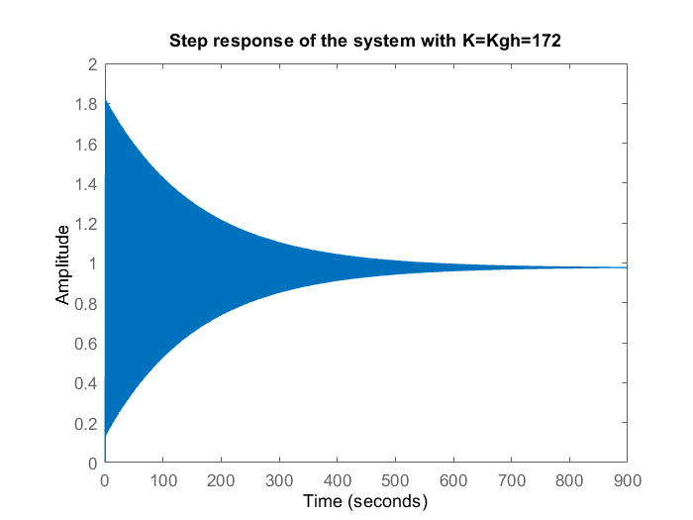

Figure : Step response of the system with K=172

* From the graph, we can see that the output does oscillate but it slowly become stable

1. ***When K=44 (POT=25%)***

Matlab code:

%% Step response of the system with K=44 (POT = 25%)

G1=tf(44,conv([1 0.2],[1 8 20]));

Gk1=feedback(G1,1);

figure;step(Gk1,5); title('Step response of the system with K=44');

S1=stepinfo(Gk1)

Result:

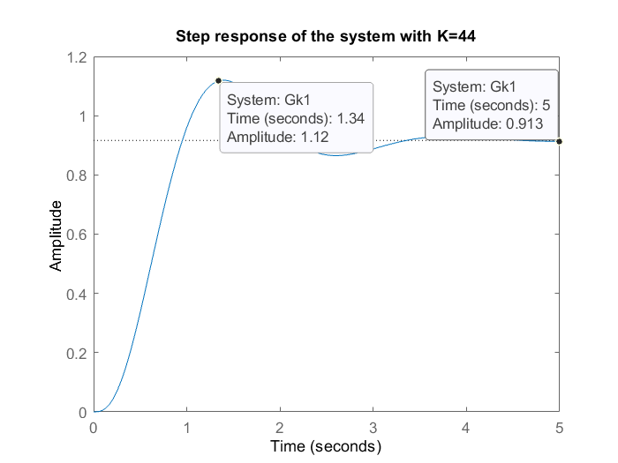

Figure : Step response of the system with K=44

* From the graph, we can see that $c_{max}=1.12 \& c_{xl}=0.913$.

Applying this equation:

|  |  |
| --- | --- |
| $$σ_{max}=\frac{c_{max}-c_{xl}}{c_{xl}}×100\%$$ | (1.3) |

* $σ_{max}=\frac{1.12-0.913}{0.913}×100\%=22.67\%$.
* We can see that although from the root locus graph we obtain K=44 in which the system will have the POT of 25% however when we plot the step response of the system the POT is slightly off the mark.

1. ***When K=52 (txl=4s)***

Matlab code:

%% Step response of the system with K=52 (txl=4s)

G2=tf(52,conv([1 0.2],[1 8 20]));

Gk2=feedback(G2,1);

figure;step(Gk2,5); title('Step response of the system with K=52');

S2=stepinfo(Gk2,'SettlingTimeThreshold',0.02)

Result:

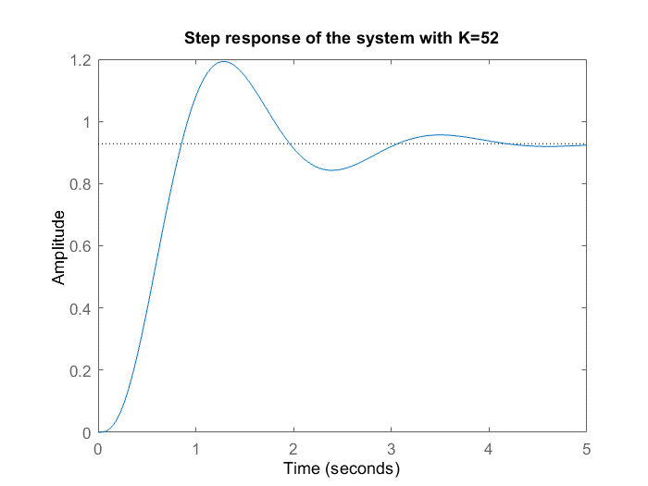

Figure : Step response of the system with K=52

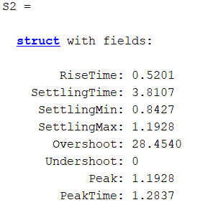

Figure : Information of the step response of the system when K=52

* From the information we can see that with K=52 this system have a settling time of 3.81s which is also a little bit far off from the requirement which is 4s.

1. ***Plot both step response for system b and c.***

Matlab code:

figure; step(Gk1,5); title('Step response of both system b and c'); hold on;

step(Gk2,5);

legend('K=44(POT 25%)','K=52(txl=4s)');

grid on;

Result:

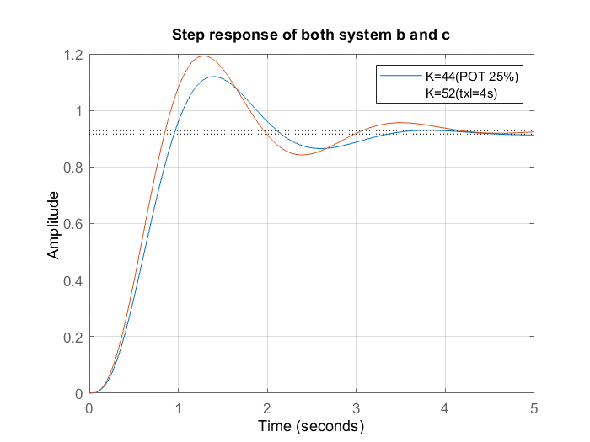

Figure : Step response of both system in question b and c

## Exercise 2

1. ***When K=Kgh(=102)***

Matlab code:

%% Step response of the system when K reached it limit at 102

G=tf([102 102],conv([1 5 0],[1 3 9]));

Gk=feedback(G,1);

figure;step(Gk); title('Step response of the system with K=Kgh=102');

Result:

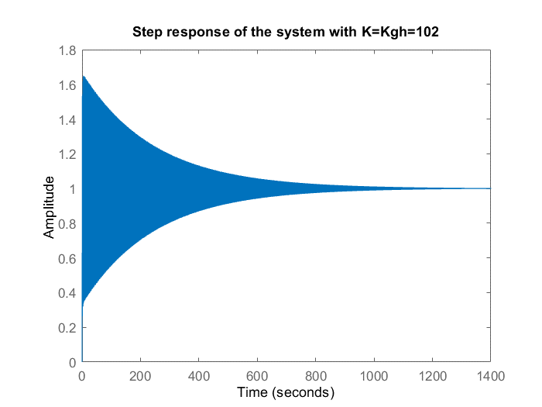

Figure : Step response of the system with K=102

1. ***When K=9.21(POT=25%)***

Matlab code:

%% Step response of the system with K=9.21 (POT = 25%)

G1=tf([9.21 9.21],conv([1 5 0],[1 3 9]));

Gk1=feedback(G1,1);

figure;step(Gk1); title('Step response of the system with K=9.21');

S1=stepinfo(Gk1)

Result:

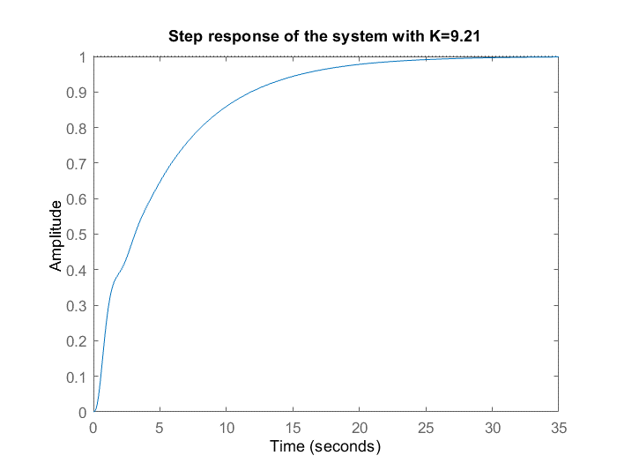

Figure : Step response of the system with K=9.21

* There is no overshoot in this system and thus we can conclude that with K=9.21, the system does not meet the requirement of $σ_{max}=25\%$.

1. ***When K=19.2 (txl=4s)***

Matlab code:

%% Step response of the system with K=19.2 (txl=4s)

G2=tf([19.2 19.2], conv([1 5 0],[1 3 9]));

Gk2=feedback(G2,1);

figure;step(Gk2,5); title('Step response of the system with K=19.2');

S2=stepinfo(Gk2,'SettlingTimeThreshold',0.02)

Result:

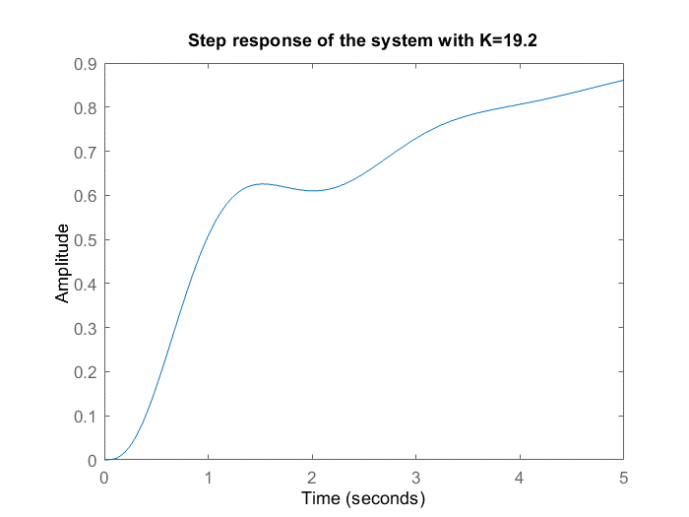

Figure : Step response of the system with K=19.2

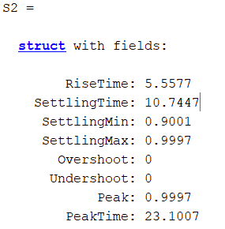

Figure : Information about the step response of the system with K=19.2

* From the information in figure 9, we can see that with the settling time of 10.75s, K=19.2 does not meet the system requirement which is 4 seconds.

1. ***Plot both step response for system b and system c***

Matlab code:

%% Plot both step response from b and c

figure; step(Gk1,5); title('Step response of both system b and c'); hold on;

step(Gk2,5);

legend('K=9.21(POT 25%)','K=19.2(txl=4s)');

grid on;

Result:

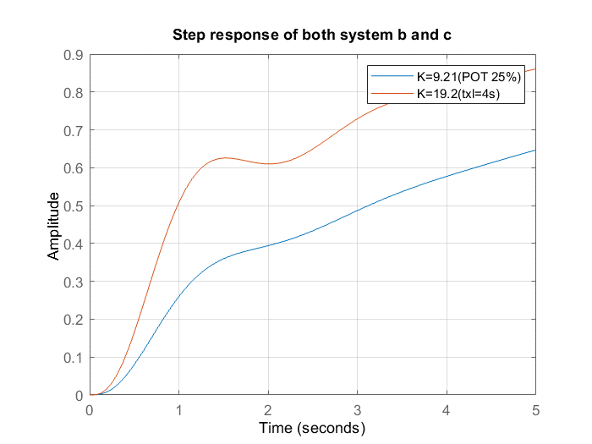

Figure : Step response of both system in question b and c

## Exercise 3:

**Question 1:** By surveying the quality of the system we can find out the overshoot, steady state error, response time,… and with all those information we can either adjust the system or choose a better system for what we require.

**Question 2:** When a system has an ideal integral, it is called a first order zero error system

**Question 3:** When the system has 2 ideal integrals, it is called a second order zero error system

**Question 4:** When the system has a pair of decision poles located on the real axis of the root locus graph.

**Question 5:** When the system has a pair of decision poles located on the imaginary axis of the root locus graph, the determination error will not be 0 and it will ve calculated with the following formula:

$$e_{xl}=cosΦ$$